Capture.jpg:

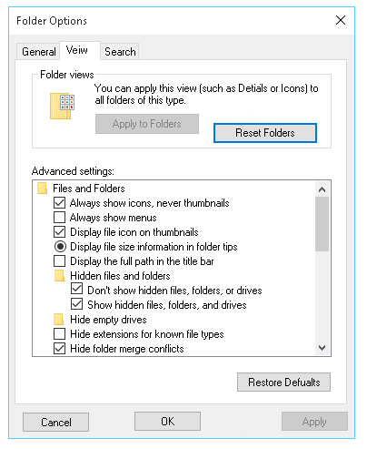

1. Tab “Veiw” >> Tab “View”
2. Folders view section >> Allign buttons in a row
3. In “Folders view” section correct text “…such as Detials…” >> …such as Details…”
4. Button “Restore Dafualts” >> “Restore Defaults”
5. All buttons in the bottom of window should be centered between each other
6. There is incompatible check-boxes and radio buttons in “Advanced settings” section. However, in “Hidden files and folders” should be radio buttons instead of check-box.
7. Change “Drives” >> for “Drivers”

[earth_148070_viewingoptions_en.jpg](http://savesoftwaretesting.com/moodle/pluginfile.php/3585/mod_folder/content/0/Screenshots/earth_148070_viewingoptions_en.jpg?forcedownload=1)

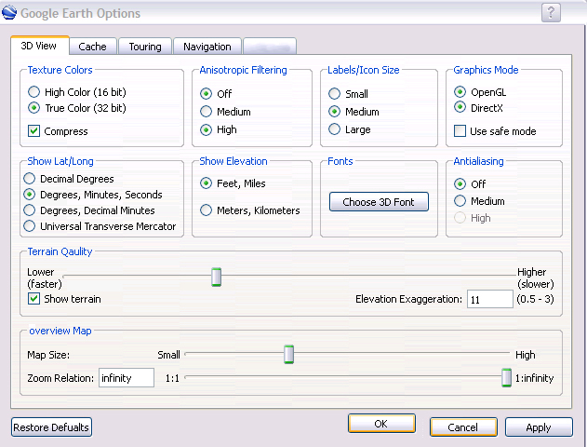

1. Last tab does hot have name or has been deleted
2. Tab “3D View” – Section “Terrain Qaulity” >> change for “Terrain Quality”
3. Tab “3D View” – Section “overview Map” >> change for “Overview Map”
4. Bottom button “Restore Defualts” >> change for “Restore Defaults”
5. All bottom buttons should be disposed in one row
6. Space between buttons “OK”, “Cancel”, “Apply” must be equal
7. In the top right corner button “?” shift a little right.

history-prefs.jpg

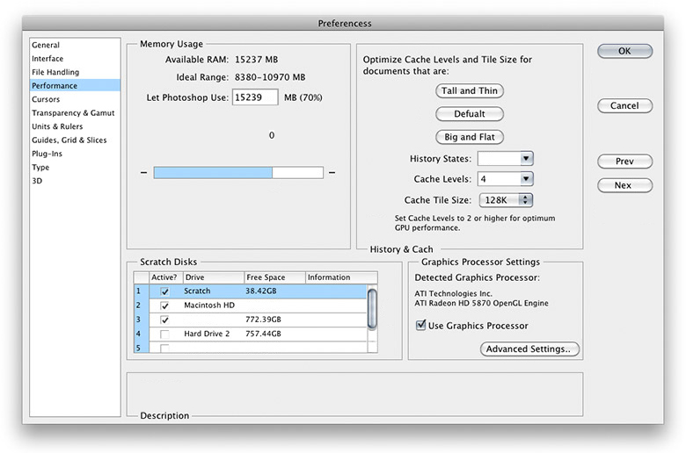

1. It the top of window name “Preferencess” >> “Preferences”
2. Right side of window there is four buttons disposed in column. Probably, buttons “OK” and “Cancel” must be near each other. Last button “Nex” >> change for “Next”
3. Int Memory usage section entered value 15239 that more than “Available RAM” and this value shows only 70% of using RAM. Progress bar in this section does not show start and finish. Some “0” non-understandable in this section.
4. In Scratch disks there is 5 check-boxes , however check-box “5” is empty string. Probably should be deleted
5. Right from “Memory Usage” section there is “History & Cach” >> change for correct word “History & Cache” and dispose this name similar like “Memory Usage” – in the top and left closer of section. There is 3 buttons where second has “Defualt” >> change for “Default”
6. In the bottom of window there is “Description” section. Dispose name “Description” like another sections in this window – on the top and close to left of section.

[macosx107-wifi-network.jpg](http://savesoftwaretesting.com/moodle/pluginfile.php/3585/mod_folder/content/0/Screenshots/macosx107-wifi-network.jpg?forcedownload=1)

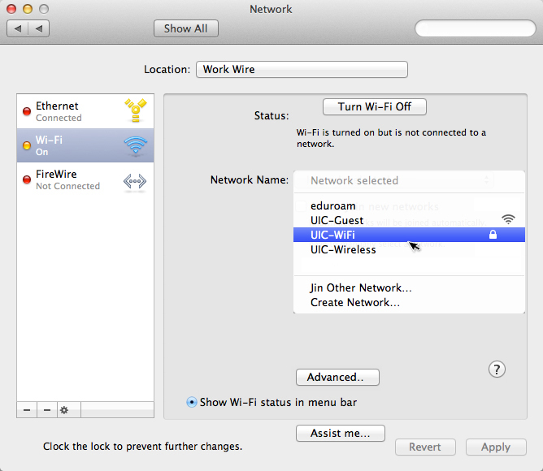

1. In the top of window there is “Show all” button which should be disposed right near search bar.
2. In the section where “Status” there is need to be changed button “Turn Wi-Fi Off” >> change “Turn Off Wi-Fi”. This button must be on the one row with the “Status” name. In the same section in drop-down menu “Network Name” there is mistake “Jin Other Network” >> change for “Join Other Network”. In this section buttons “Advanced” and “?” probably must be in the right low corner and disposed in one row with each other with little space between this two buttons
3. In the left section of status bar and down of it there is two minus “-“. Probably one of them must be deleted of corrected for another one button.
4. In the down of window all of three buttons must be disposed in one row with equal spaces between them. “Clock the…” >> change for “Click …”

[osx-terminal-preferences-settings-tab-advanced-sub-tab.jpg](http://savesoftwaretesting.com/moodle/pluginfile.php/3585/mod_folder/content/0/Screenshots/osx-terminal-preferences-settings-tab-advanced-sub-tab.jpg?forcedownload=1)

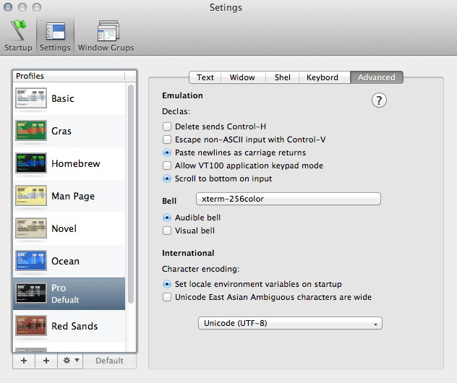

1. On the top in center of window “Setings” >> change for “Settings”. Left and a little down there is 3 buttons. One of them “Window Grups” >> change “Window Groups”
2. In “Profiles” section in list find “Pro-Defualt” >> change for “Pro-Default”. In the same section in the bottom there is two buttons “+”. Probably must be changed for “+” and “-“.
3. In the Tabs section there Is five tabs names of them must be corrected: “Widow” >> correct for “Window”, “Shel” >> correct for “Shell”, “Keybord” >> correct for “Keyboard”. “?” change dispose to the bottom and right. Check-boxes and radio buttons must be separate or make all in one style

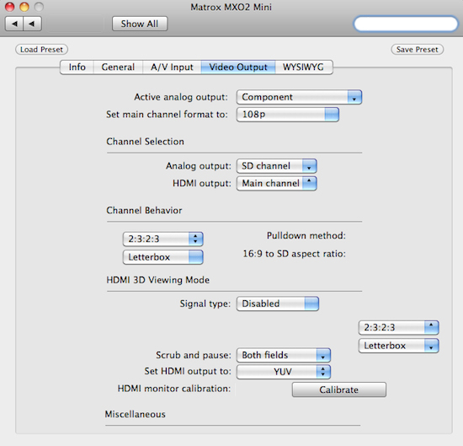

ppro-matrox-settings.jpg

1. In the top shift “Show all” to right near search bar.
2. The Tab section Is not correct designed.

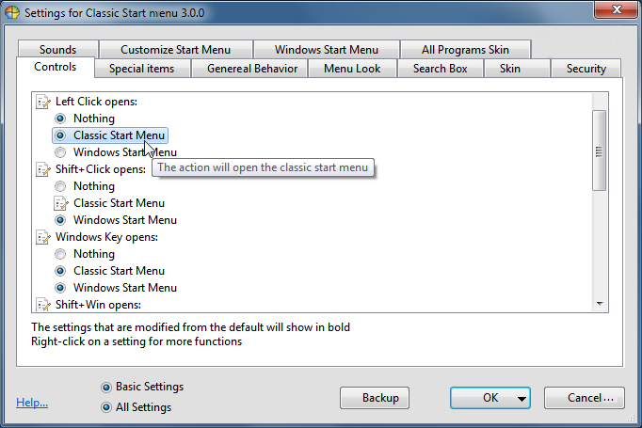

StartMenuSettings.jpg

1. In Tabs section “Genereal Behavior” >> change for “General Behavior”
2. In “Controls” tab section there is should be all radio buttons
3. In the bottom of general window all buttons must be near from each other and have equal spase between them. Here 2 radio buttons can not be switch on simultaneously.

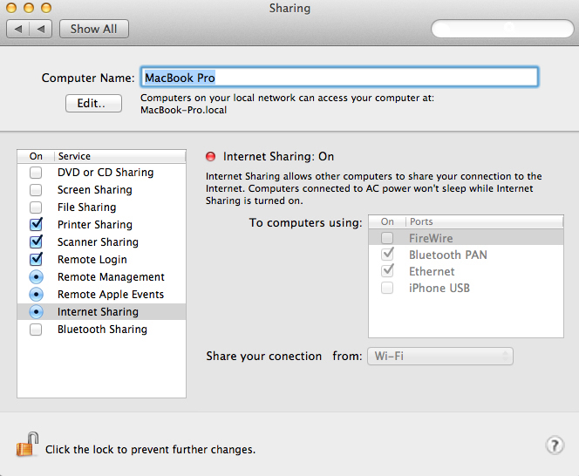

[vEDjw.jpg](http://savesoftwaretesting.com/moodle/pluginfile.php/3585/mod_folder/content/0/Screenshots/vEDjw.jpg?forcedownload=1)

1. In check-box window there is radio buttons with check-boxes. However, they must be separated.
2. In the bottom near “Click the lock….” Can’t see “Lock” button.
3. In general window under “Internet Sharing On” you see “Share your conection” >> correct for ”Share your connection”.

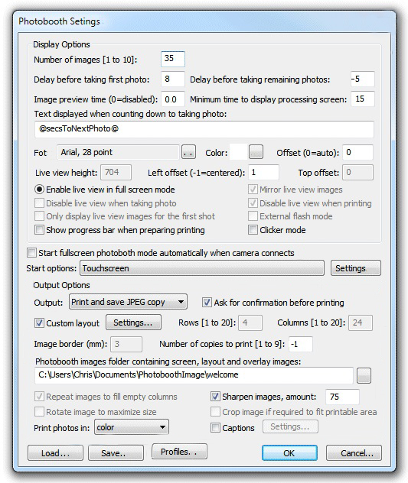

welcome_settings.jpg

1. In the bottom there is left three buttons must be in row with equal space between them.
2. In section “Photobooth images folder…” right there is a button to choose the path and button should contain “…”.